**Assignment 1 (Part A) Submission**

**Name:** Tanishq Prasad

**Roll number:** 21CS30054

**Link of the pcap file:** https://drive.google.com/file/d/1nEs4Hq9zbtEOL7i7i6mbIFkP79YenWn8/view?usp=drive_link

1)

1. TCP = 16321 packets

UDP = 384 packets

In Total = 16705 packets

1. IPv4 = 16705

IPv6 = 0

2)

a) <http://iitkgp.ac.in/> had the IP address as - 172.16.3.10

Packets received = 7870

The total amount of data = 12257711 bytes

b) <https://www.cornell.edu/> had two IP addresses

1. 13.107.246.72

* Packets received = 2
* The total amount of data = 148 bytes

1. 13.107.213.72

* Packets received = 15
* The total amount of data = 1374 bytes

3) Total DNS packets = 332

1. The table is attached as screenshots:-

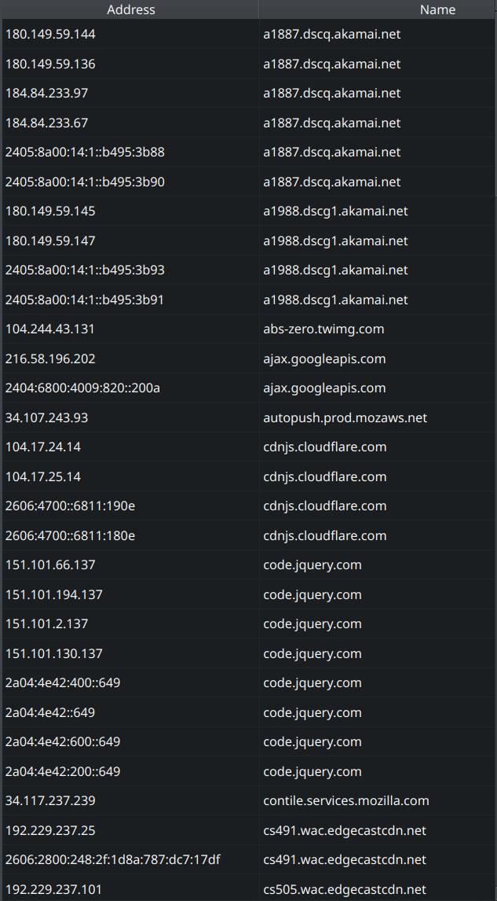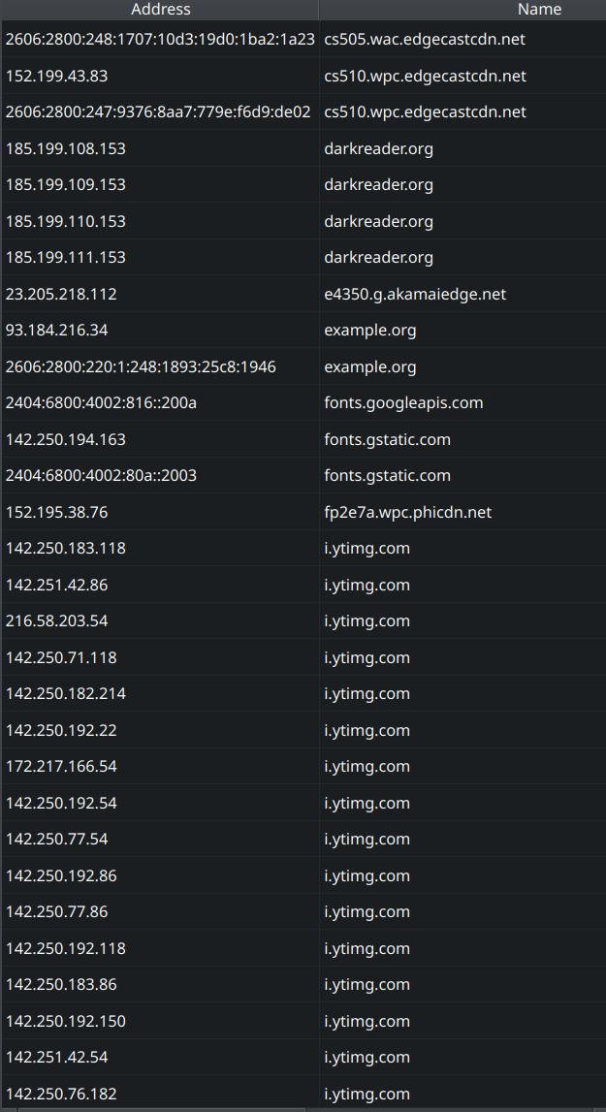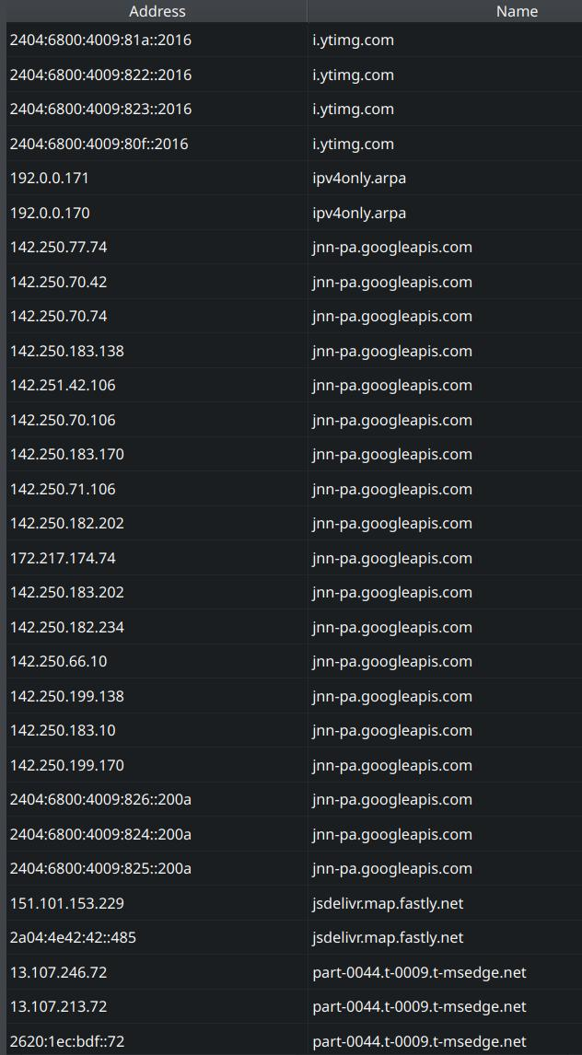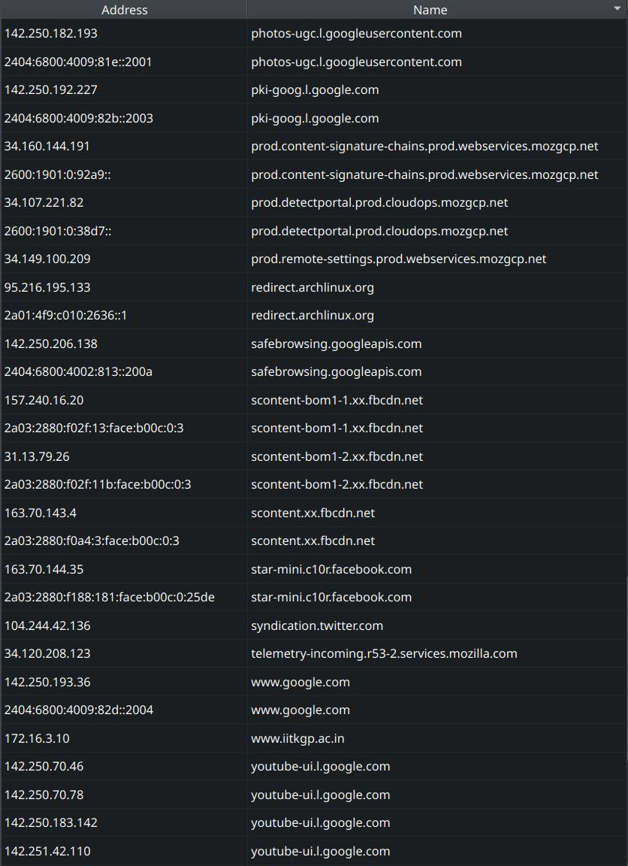



1. Yes, we can find the IP of the DNS servers by looking at the Source of DNS query responses or the Destination of the DNS queries.

It was seen that 172.16.1.166 was the only one.

4) While accessing <http://iitkgp.ac.in/> :-

1. 5 HTTP GET requests were observed



| **Packet No.** | **Response Packet No.** | **TCP Segments** | **Total Data (in bytes)** |
| --- | --- | --- | --- |
| 311 | 932 | 293 | 433222 |
| 1162 | 5241 | 300 | 433214 |
| 3590 | 4454 | 14 | 19691 |
| 7761 | No Response | 0 | 0 |
| 9750 | No Response | 0 | 0 |